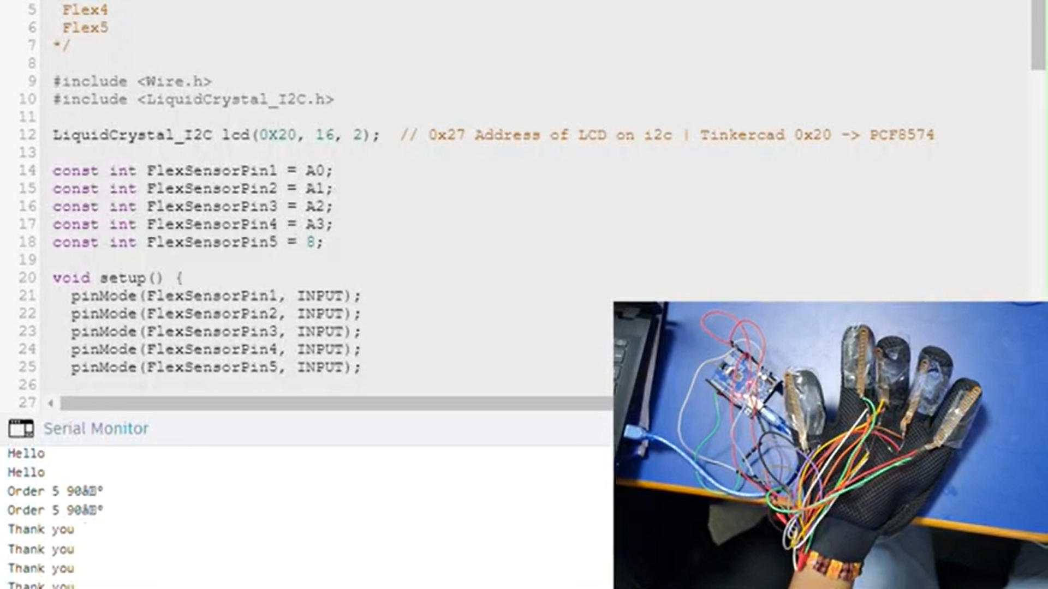**PROTOTYPE OF THE PROJECT**